Lecture: 1.3.6: Algebra of Logic:
Course outcome to be covered:
CO1: Apply and recognized about the Logics

Algebra of Logic:
It is the branch of mathematical logic that deals with propositions from the aspect of their logical meanings (true or false) and with logical operations on them. The algebra of logic originated in the middle of the 19th century with the studies of G.
In mathematical logic, algebraic logic is the reasoning obtained by manipulating equations with free variables.
What is now usually called classical algebraic logic focuses on the identification and algebraic description of models appropriate for the study of various logics (in the form of classes of algebras that constitute the algebraic semantics for these deductive systems) and connected problems like representation and duality. Well known results like the representation theorem for Boolean algebras and Stone duality fall under the umbrella of classical algebraic logic.
In specifying the functions of the algebra of logic one often uses tables which contain all the combinations of the values of the variables and the values of the functions on these combinations. Thus, the synoptic table of the functions , , , , and is given below:
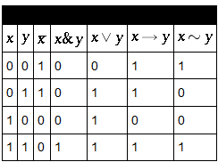
Tables for arbitrary functions of the algebra of logic are constructed in a similar manner. This is the so-called tabular way of specifying functions of the algebra of logic. The tables themselves are sometimes called truth tables. The following equalities play an important part in the transformations of formulas into equivalent formulas:
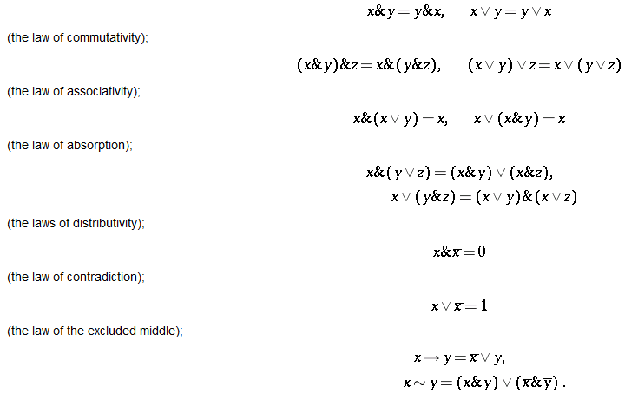
The rules of mathematical logic specify methods of reasoning mathematical statements. Greek philosopher, Aristotle, was the pioneer of logical reasoning. Logical reasoning provides the theoretical base for many areas of mathematics and consequently computer science. It has many practical applications in computer science like design of computing machines, artificial intelligence, definition of data structures for programming languages etc.
Propositional Logic is concerned with statements to which the truth values, “true” and “false”, can be assigned. The purpose is to analyze these statements either individually or in a composite manner.

Prepositional Logic – Definition
A proposition is a collection of declarative statements that has either a truth value "true” or a truth value "false". A propositional consists of propositional variables and connectives. We denote the propositional variables by capital letters (A, B, etc). The connectives connect the propositional variables.
Some examples of Propositions are given below −
- "Man is Mortal", it returns truth value “TRUE”
- "12 + 9 = 3 – 2", it returns truth value “FALSE”
The following is not a Proposition −
- "A is less than 2". It is because unless we give a specific value of A, we cannot say whether the statement is true or false.

Connectives
In propositional logic generally we use five connectives which are –
OR (∨)
AND (∧)
Negation/ NOT (¬)
Implication / if-then (→)
If and only if (⇔).
OR (∨)
The OR operation of two propositions A and B (written as A ∨ B) is true if at least any of the propositional variable A or B is true.
The truth table is as follows −
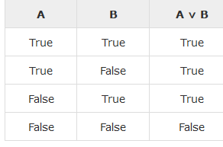
AND (∧)
The AND operation of two propositions A and B (written as A ∧ B) is true if both the propositional variable A and B is true.
The truth table is as follows −
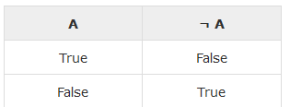
Implication / if-then (→)
An implication A → B is the proposition “if A, then B”. It is false if A is true and B is false. The rest cases are true.
The truth table is as follows –
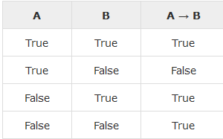
If and only if (⇔)
A⇔B is bi-conditional logical connective which is true when p and q are same, i.e. both are false or both are true.
The truth table is as follows −
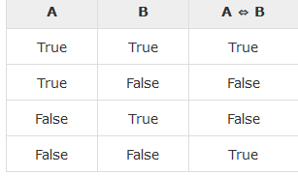

Tautologies
A Tautology is a formula which is always true for every value of its propositional variables. Example − Prove [(A→B) ∧ A] → B is a tautology.
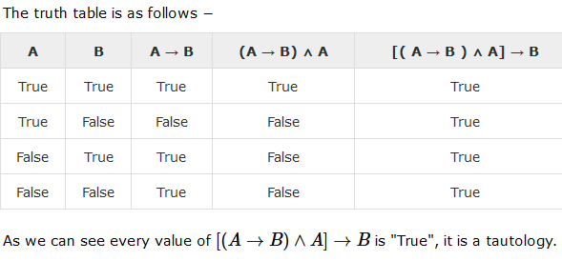
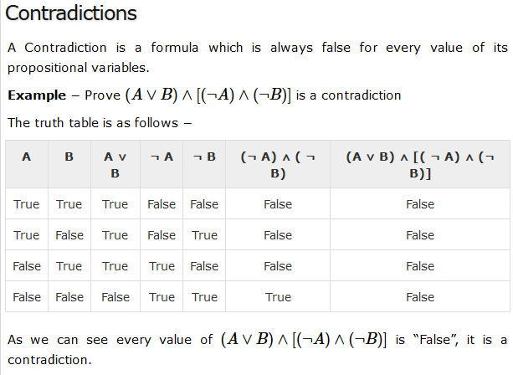
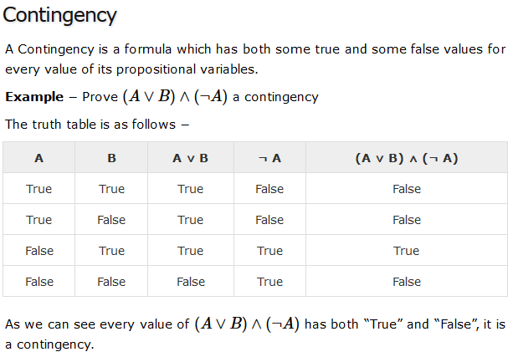
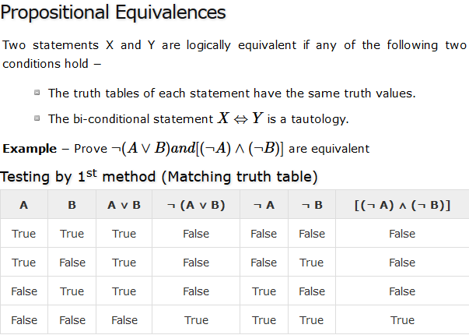
Here, we can see the truth values of ¬ (A ∨ B) and [(¬A) ∧ (¬B)] are same, hence the statements are equivalent.
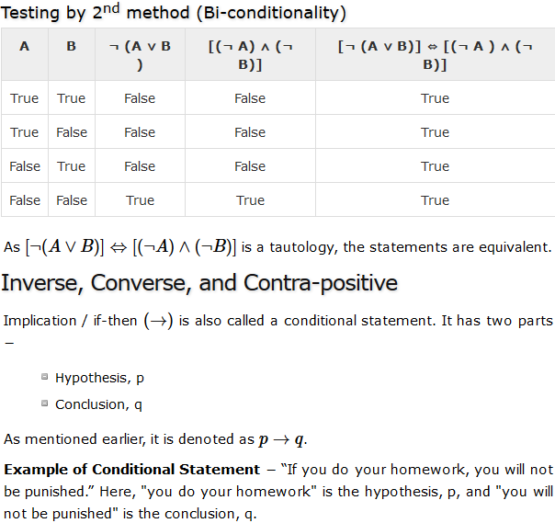
Inverse − An inverse of the conditional statement is the negation of both the hypothesis and the conclusion. If the statement is “If p, then q”, the inverse will be “If not p, then not q”. Thus the inverse of p → q is ¬ p → ¬ q
.Example − The inverse of “If you do your homework, you will not be punished” is “If you do not do your homework, you will be punished.”
Converse − The converse of the conditional statement is computed by interchanging the hypothesis and the conclusion. If the statement is “If p, then q”, the converse will be “If q, then p”. The converse of p → q is q → p.
Example − The converse of "If you do your homework, you will not be punished" is "If you will not be punished, you do not do your homework”.
Contra-positive − The contra-positive of the conditional is computed by interchanging the hypothesis and the conclusion of the inverse statement. If the statement is “If p, then q”, the contra-positive will be “If not q, then not p”. The contra-positive of p → q is ¬q → ¬p.
Example − The Contra-positive of " If you do your homework, you will not be punished” is "If you are not punished, then you do not do your homework”.

Duality Principle
Duality principle states that for any true statement, the dual statement obtained by interchanging unions into intersections (and vice versa) and interchanging Universal set into Null set (and vice versa) is also true. If dual of any statement is the statement itself, it is said self-dual statement.
Example − The dual of (A ∩ B) ∪ C is (A ∪ B) ∩ C.

Normal Forms
We can convert any proposition in two normal forms −
- Conjunctive normal form
- Disjunctive normal form

Conjunctive Normal Form
A compound statement is in conjunctive normal form if it is obtained by operating AND among variables (negation of variables included) connected with ORs. In terms of set operations, it is a compound statement obtained by Intersection among variables connected with Unions.
Examples
1. (A ∨ B) ∧ (A ∨ C) ∧ (B ∨ C ∨ D)
2. (P ∪ Q) ∩ (Q ∪ R).

Disjunctive Normal Form
A compound statement is in conjunctive normal form if it is obtained by operating OR among variables (negation of variables included) connected with ANDs. In terms of set operations, it is a compound statement obtained by Union among variables connected with Intersections.
Examples
1. (A ∧ B) ∨ (A ∧ C) ∨ (B ∧ C ∧ D)
2. (P ∩ Q) ∪ (Q ∩ R).

